LAB # 09

Generics in C#

Generics
Generic means the general form, not specific. In C#, generic means not specific to a particular data type.
Generics allow you to define the specification of the data type of programming elements in a class or a method, until it is actually used in the program. In other words, generics allow you to write a class or method that can work with any data type. C# Generics allow us to create a single class or method that can be used with different types of data. This helps us to reuse our code.
C# allows you to define generic classes, interfaces, abstract classes, fields, methods, static methods, properties, events, delegates, and operators using the type parameter and without the specific data type. A type parameter is a placeholder for a particular type specified when creating an instance of the generic type.
A generic type is declared by specifying a type parameter in an angle brackets after a type name, e.g. TypeName<T> where T is a type parameter.

Generic Class
Generic classes are defined using a type parameter in an angle brackets after the class name. The following defines a generic class.

public class Student<T>
{
private T value;

public T Value
{
get { return value; }
set { this.value = value; }
}
}
Here, we have created a generics class named Student. T used inside the angle bracket is called the type parameter.
While creating an instance of the class, we specify the data type of the object which replaces the type parameter.
// create an instance with data type string
Student<string> studentName = new Student<string>();
// create an instance with data type int
Student<int> studentId = new Student<int>();

The System.Collection.Generic namespace also defines a number of classes that implement many of these key interfaces. The following table describes the core class types of this namespace.
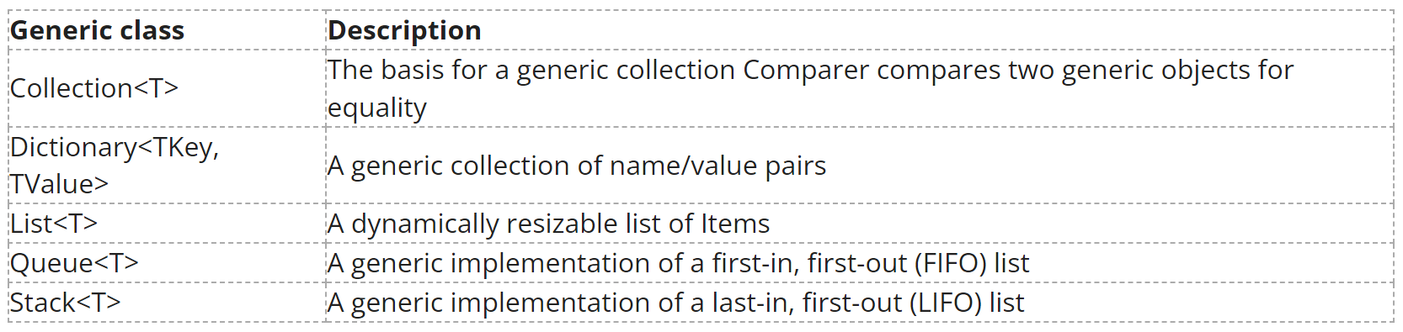

Example-1
using System;
namespace ConsoleApp7
{
// define a generics class named Student
public class Student<T>
{
// define a variable of type T
public T data;

// define a constructor of the Student class
public Student(T data)
{
this.data = data;
Console.WriteLine("Data passed: " + this.data);
}
}
class Program
{
static void Main(string[] args)
{
// create an instance with data type string
Student<string> studentName = new Student<string>("John");

// create an instance with data type int
Student<int> studentId = new Student<int>(13);
}
}
}

Output:
Data passed: John
Data passed: 13

Generic Methods
Similar to the generics class, we can also create a method that can be used with any type of data. Such a class is known as the generics method. You can also create custom generic types and methods to provide your own generalized solutions and design patterns that are type-safe and efficient.

For example,
public void displayData(T data)
{
Console.WriteLine("Data Passed: " + data);
}

Example-2
using System;
// define a generics class named Employee
class Employee<T>
{
// define a generics method that displays the passed data
public void displayData(T data)
{
Console.WriteLine("The data passed is: " + data);
}
}

class Program
{
static void Main()
{
// create an instance of Employee class by specifying T as string
Employee<string> employeeName = new Employee<string>();

// call displayData() generics method and pass a string value - "Jack"
employeeName.displayData("Jack");

// create an instance of Employee class by specifying T as int
Employee<int> employeeId = new Employee<int>();

// call displayData() generics method and pass an integer value
employeeId.displayData(123);
}
}

Output:
The data passed is: Jack
The data passed is: 123

Example-3
using System;
// define a generics class named Employee
class Movie<T>
{
// define a generics method that returns T type value
public T displayData(T data)
{
return data;
}
}

class Program
{
static void Main()
{
// create an instance with data type string
Movie<string> movieName = new Movie<string>();
Console.WriteLine("Generics Method returns: " + movieName.displayData("Inception"));

// create an instance with data type int
Movie<int> movieRating = new Movie<int>();
Console.WriteLine("Generics Method returns: " + movieRating.displayData(9));
}
}

Output:
Generics Method returns: Inception
Generics Method returns: 9

The T used in place of void in displayData method allows us to return any type of data.

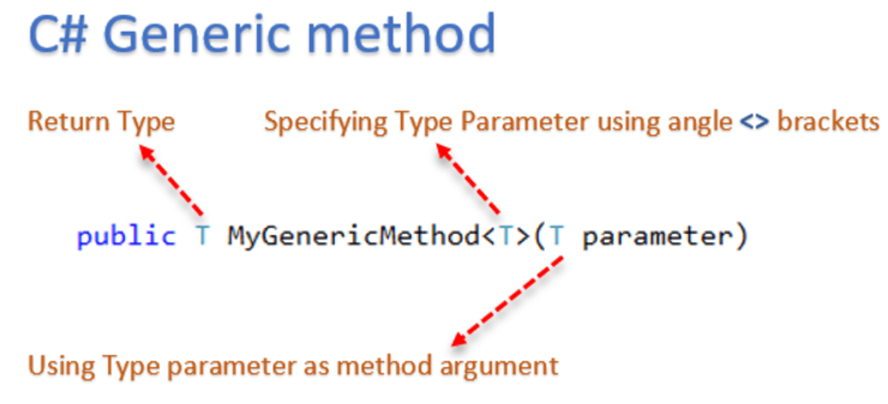

Example-4
using System;
using System.Collections.Generic;

namespace GenericApp
{
class Program
{
//Generic method
static void Swap<T>(ref T a, ref T b)
{
T temp;
temp = a;
a = b;
b = temp;
}
static void Main(string[] args)
{
// Swap of two integers.
int a = 40, b = 60;
Console.WriteLine("Before swap: {0}, {1}", a, b);

Swap<int>(ref a, ref b);

Console.WriteLine("After swap: {0}, {1}", a, b);

Console.ReadLine();
}
}
}

Output:
Before swap: 40, 60
After swap: 60, 40

Dictionary
Dictionaries are also known as maps or hash tables. It represents a data structure that allows you to access an element based on a key. One of the significant features of a dictionary is faster lookup; you can add or remove items without the performance overhead.

.Net offers several dictionary classes, for instance Dictionary<TKey, TValue>. The type parameters TKey and TValue represent the types of the keys and the values it can store, respectively.

Example-5
using System;
using System.Collections.Generic;

namespace GenericApp
{
public class Program
{
static void Main(string[] args)
{
//define Dictionary collection
Dictionary<int,string> dObj = new Dictionary<int,string>(5);

//add elements to Dictionary
dObj.Add(1,1,"Tom");
dObj.Add(2,"John");
dObj.Add(3, "Maria");
dObj.Add(4, "Max");
dObj.Add(5, "Ram");

//print data
for (int i = 1; i <= dObj.Count;i++)
{
Console.WriteLine(dObj[i]);
}
Console.ReadKey();
}
}
}

Lab Tasks

- Write a generic method, Search, that implements the linear-search algorithm. Method Search should compare the search key with each element in its array parameter until the search key is found or until the end of the array is reached. If the search key is found, return its location in the array; otherwise, return -1. Write a test app that inputs and searches an int array and a double array. Provide buttons that the user can click to randomly generate int and double values. Display the generated values in a TextBox, so the user knows what values they can search for [Hint: Use (T : IComparable< T >) in the where clause for method Search so that you can use method CompareTo to compare the search key to the elements in the array.] contain void showTransaction(), double getAmount(),
- Write a simple generic version of method IsEqualTo that compares its two arguments with the Equals method, and returns true if they’re equal and false otherwise. Use this generic method in a program that calls IsEqualTo with a variety of simple types, such as object or int. What result do you get when you attempt to run this program?
- Write a generic class Pair which has two type parameters, F and S, representing the type of the first and second element of the pair, respectively. Add properties for the first and second elements of the pair. [Hint: The class header should be public class Pair<F, S>.]

